**Dual Port RAM (RTL to GDSII) 3EC610IE24 – Physical Design for CMOS Technology**

Special Assignment Project Report

**MINOR IN**

**VLSI DESIGN**

By

**Heer Ramavat (22BCE296)**



**Department of Electronics and Communication Engineering, Institute of Technology,**

**Nirma University, Ahmedabad- 382481**

# Introduction

**What is Dual Port RAM?**

**Dual Port RAM** is a type of Random Access Memory that allows **simultaneous access to two different memory locations** through **two separate ports**. This makes it especially useful in applications requiring high-speed data processing and communication between two independent systems or processes.

## Key Features:

* **Two independent ports (Port A and Port B)** Each port can have its own address, data, and control lines.
* **Concurrent Read/Write** Both ports can perform read or write operations at the same time (with some restrictions if they access the same address).

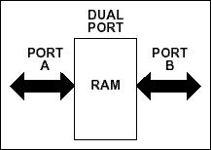

## Applications:

* FIFO buffers
* Video/image processing
* Dual-processor systems
* Communication between clock domains (asynchronous dual port RAM)

# Simulation in NC launch (Cadence Tool)

## a. Design in Verilog Code (.v file)

`timescale 1ns / 1ps

module dual_port_ram1(

//it has two sets of address and data bus, input [7:0] data_a, data_b, //input data

input [5:0] addr_a, addr_b, //Port A and Port B address input we_a, we_b, //write enable for Port A and Port B input clock,reset, //clk

output reg [7:0] q_a, q_b //output data at Port A and Port B

);

reg [7:0] ram [63:0]; //8*64 bit ram always @(posedge clock)

begin

if (reset) begin

q_a <= 0;

q_b <= 0;

end

end

always @ (posedge clock)

begin if(we_a)

ram[addr_a] <= data_a; else

q_a <= ram[addr_a]; end

always @ (posedge clock) begin

if(we_b)

ram[addr_b] <= data_b; else

q_b <= ram[addr_b]; end

endmodule

**Testbench in Verilog Code (.v file)**

`timescale 1ns / 1ps

module dual_port_ram1_tb();

reg [7:0] data_a, data_b; //input data

reg [5:0] addr_a, addr_b; //Port A and Port B address reg we_a, we_b; //write enable for Port A and Port B reg clock, reset; //clk

wire [7:0] q_a, q_b; //output data at Port A and Port B

dual_port_ram1 dual_port_ram( .data_a(data_a), .data_b(data_b), .addr_a(addr_a), .addr_b(addr_b), .we_a(we_a), .we_b(we_b), .clock(clock), .reset(reset), .q_a(q_a), .q_b(q_b) );

initial

begin clock=1'b0;

forever #5 clock = ~clock; end

initial begin

reset = 1'b1; #10;

reset = 1'b0;

we_a = 1'b1; we_b = 1'b1;

data_a = 8'h33; addr_a = 6'h01;

data_b = 8'h44; addr_b = 6'h02;

#10;

we_a= 1'b0;

addr_a = 6'h01; //read a

#10

we_b = 1'b0;

addr_b = 6'h02;//read b #10;

we_a = 1'b1; we_b = 1'b1;

data_a = 8'h55; addr_a = 6'h04;

data_b = 8'h66; addr_b = 6'h05;

#10

we_a = 1'b0;

addr_a = 6'h04; //read a

#10

we_b = 1'b0; addr_b = 6'h05;

#100;

$finish; end

**Waveform**

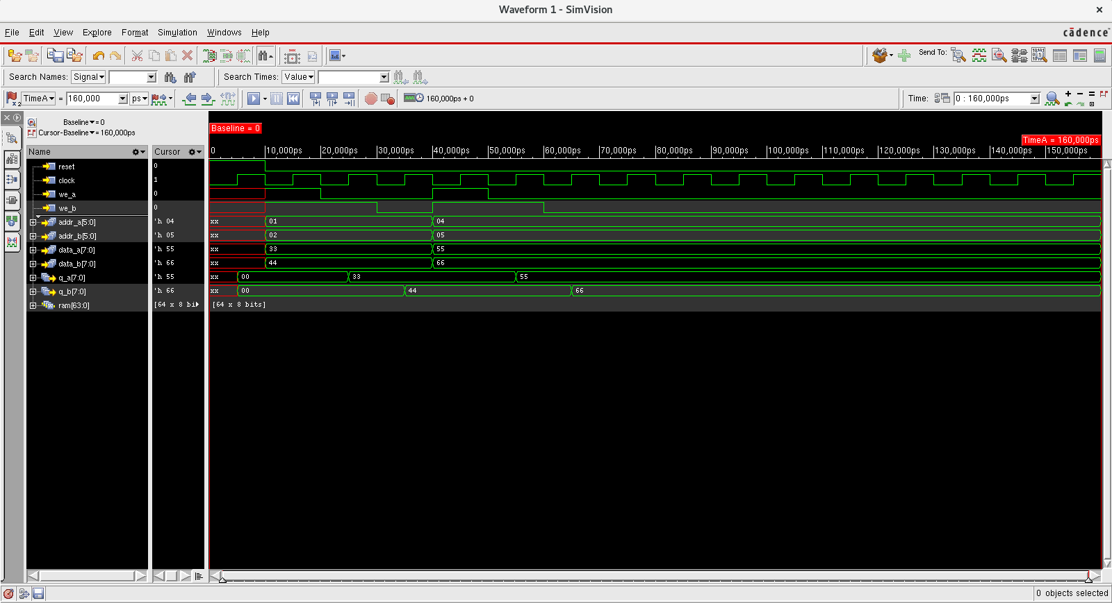



# Synthesis in Genus (Cadence Tool)

## TCL File Development (run.tcl file)

set_db lib_search_path /home/install/FOUNDRY/digital/180nm/dig/lib

set_db hdl_search_path ./

set_db library slow.lib

read_hdl dual_port_ram.v

elaborate

read_sdc constraints_top.sdc

synthesize -to_mapped -effort medium

write_sdf -timescale ns -nonegchecks -recrem split -edges check_edge > delays.sdf

write_hdl > dual_port_ram_netlist.v

write_sdc > dual_port_ram_sdc.sdc

gui_show

report timing > dual_port_ram_timing.rep

report power > dual_port_ram_power.rep

report area > dual_port_ram_cell.rep

report messages > dual_port_ram_message.rep

## SDC File Development (constraints_top.sdc)

create_clock -name clock -period 2 -waveform {0 1} [get_ports "clock"] set_clock_transition -rise 0.1 [get_clocks "clock"]

set_clock_transition -fall 0.1 [get_clocks "clock"] set_clock_uncertainty 0.01 [get_ports "clock"]

set_input_delay -max 1.0 [get_ports "reset"] -clock [get_clocks "clock"] set_input_delay -max 1.0 [get_ports "clock"] -clock [get_clocks "clock"] set_input_delay -max 1.0 [get_ports "en"] -clock [get_clocks "clock"] set_input_delay -max 1.0 [get_ports "d"] -clock [get_clocks "clock"]

set_input_delay -max 1.0 [get_ports "dir"] -clock [get_clocks "clock"] set_output_delay -max 1.0 [get_ports "out"] "-clock" [get_clocks "clock"]

## Dual port RAM Schematic

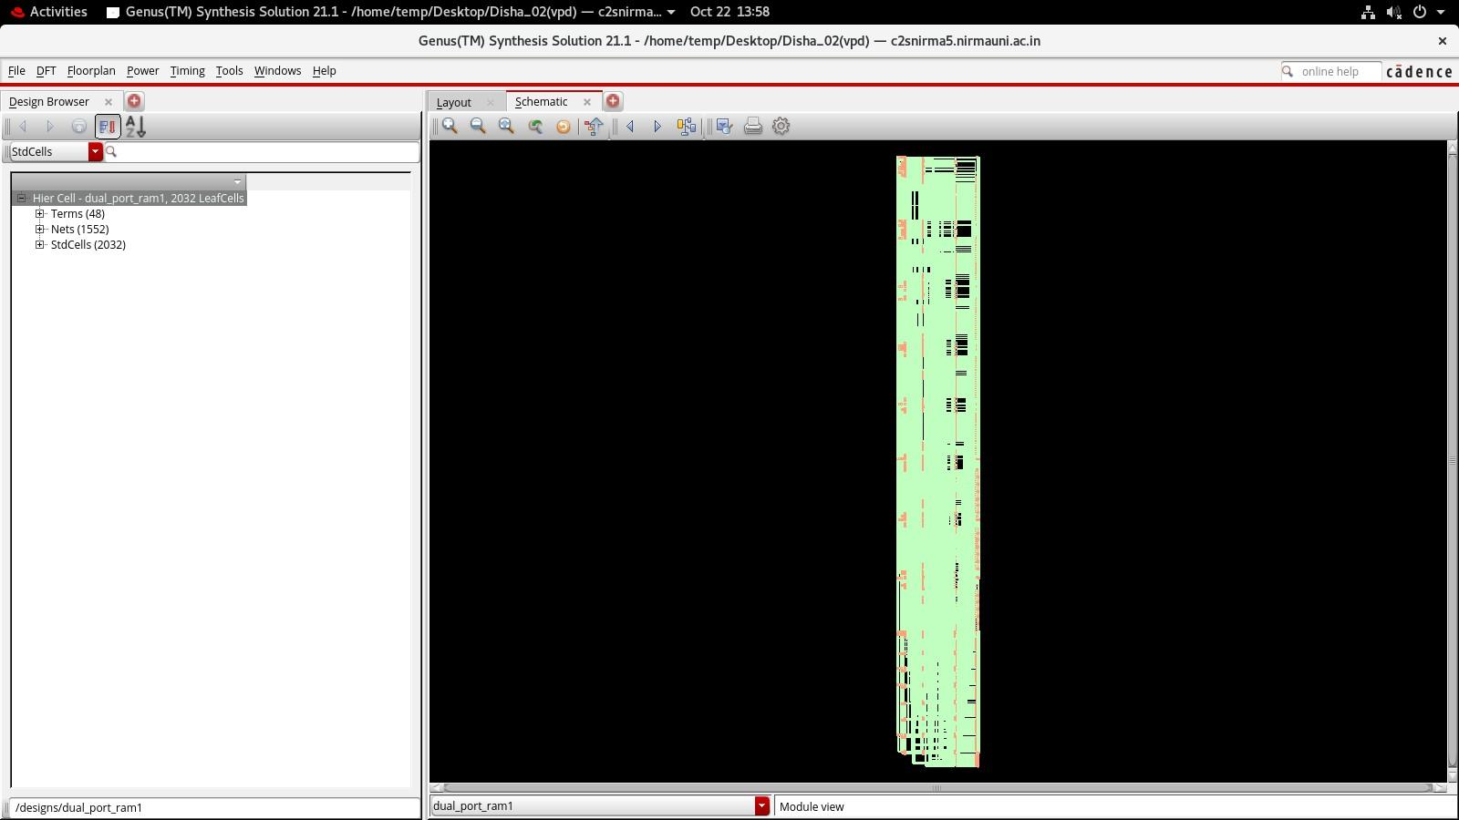

Fig: 2 Schematic in Genus tool

# ASIC flow in Innovus (Cadence Tool)

## Floor Planning

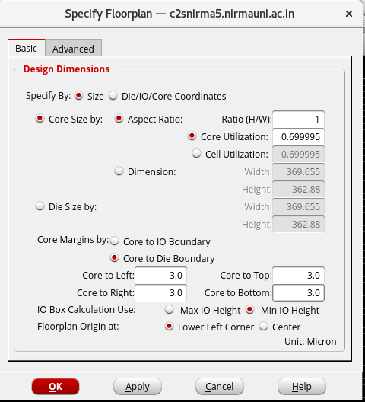

Fig. 3: Floorplanning Parameters

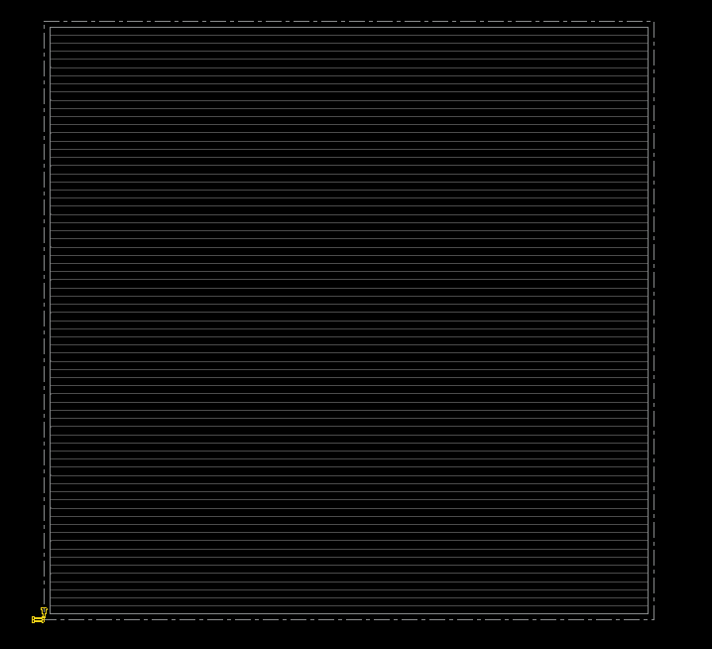

### Fig. 4: Floorplanning

## Power Planning

### Step 1: Add Rings

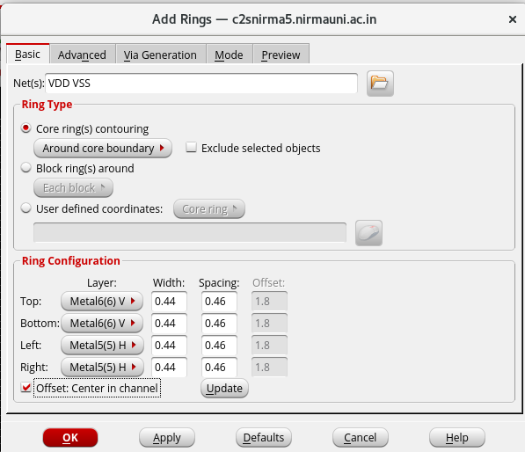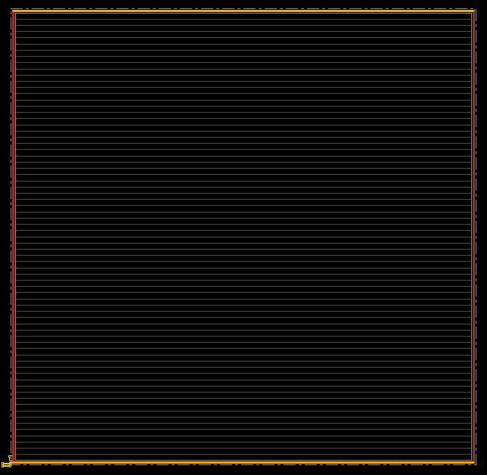

Fig.5: Power Planning (Step-1)

### Step 2: Add Strips

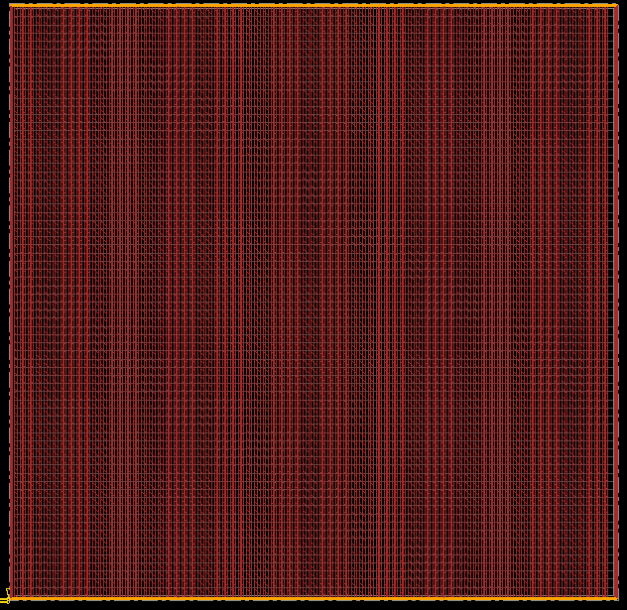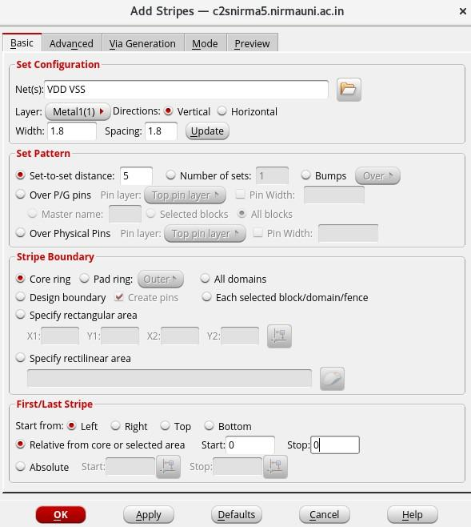

Fig. 6: Power Planning (Step-2)

### Power planning report

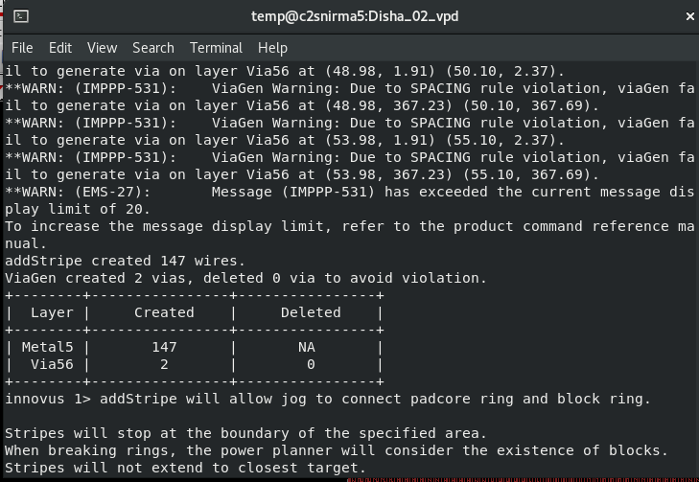

Fig. 7: Power Planning report

## Routing

### Step 3: Routing

### Fig. 8: Step- 3 Routing

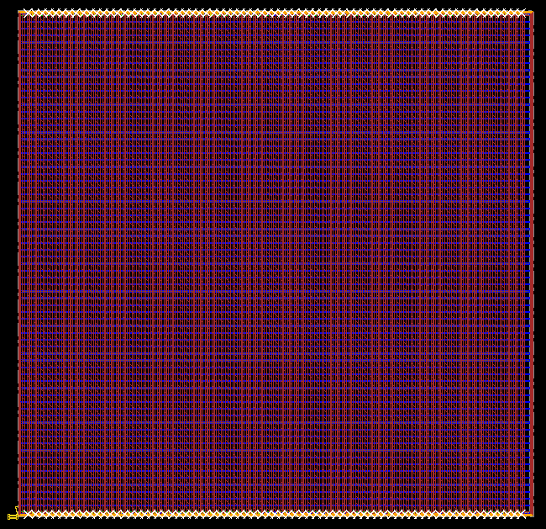

Fig. 9: Step- 3 Layout after Routing

### Routing report

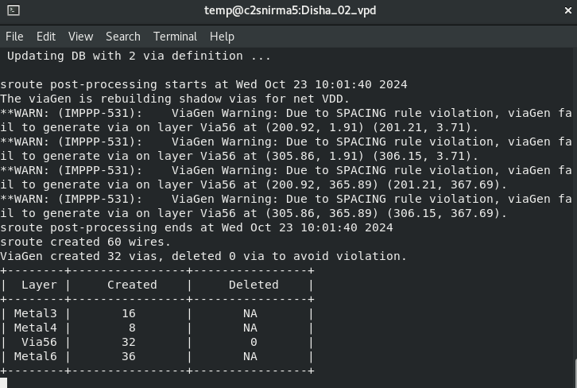

Fig 10: Routing Report

## Placement of Standard Cells

### Step 4: End Cap Placed

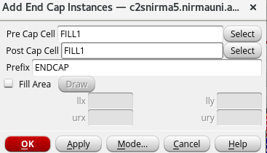 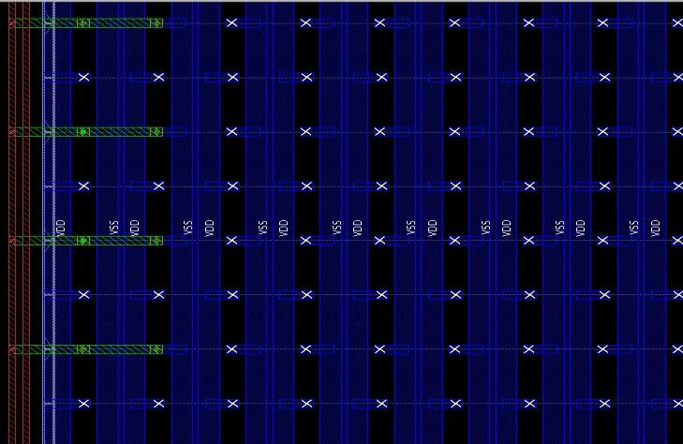

Fig. 11: Step- 4 End Cap Placed

### Step 5: Well Cells Placed

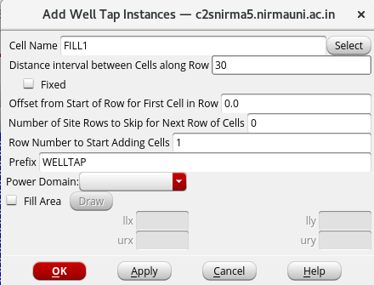

Fig. 12: Step- 5 Well Cells Placed

### Step 6: Placement of Standard Cell and Pin done

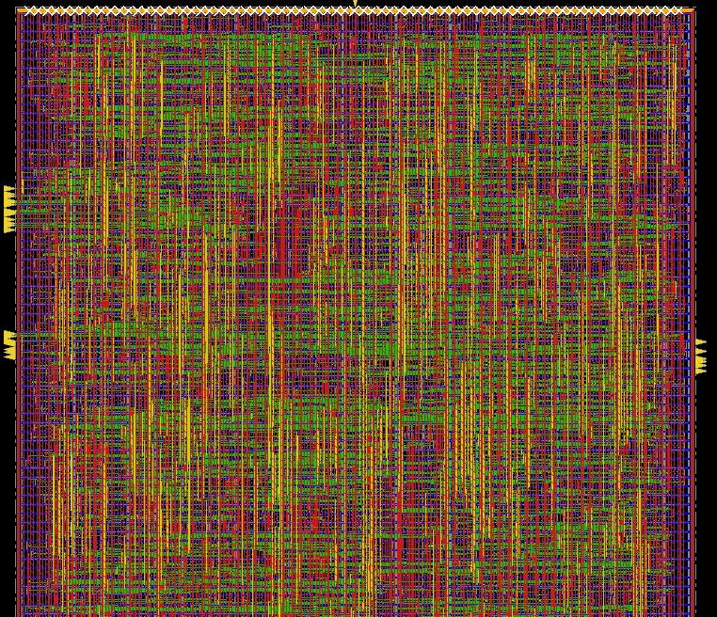

Fig. 13: Step- 6 Placement of Standard Cell and Pin done

## Pre-CTS analysis (Setup time)

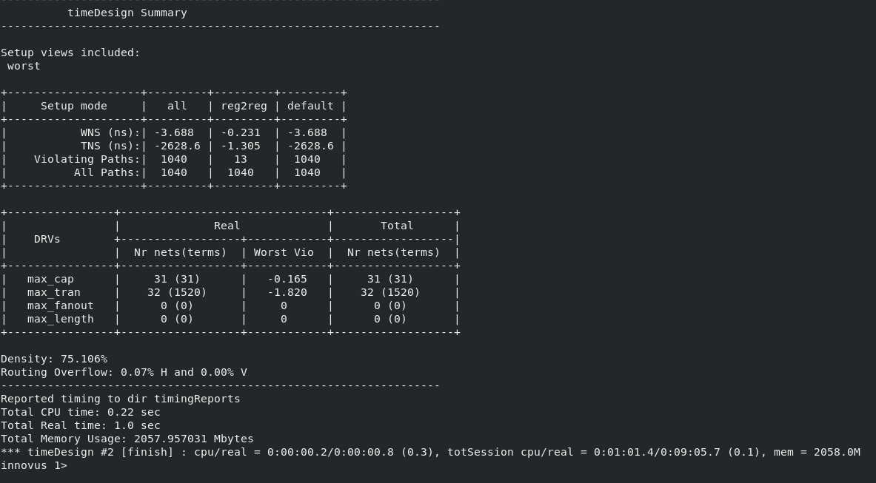

Fig. 14: Violation in Pre-CTS simulation

## Optimization of Pre-CTS Setup time Violation

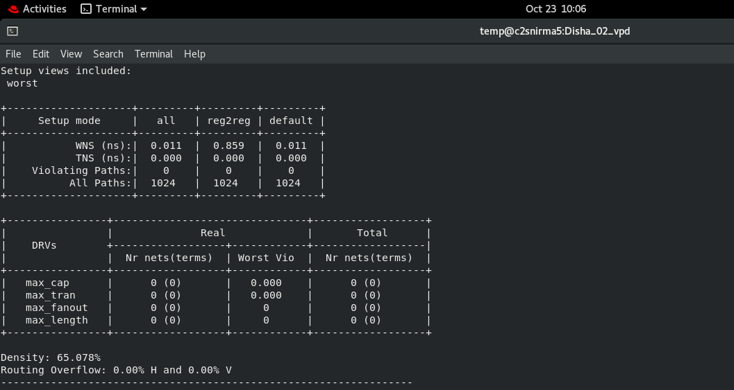

Fig. 15: Violation Removed in Pre- CTS simulation

## Clock Tree Synthesis (CTS)

### Clock tree insertion commands:

add_ndr -width {Metal1 0.12 Metal2 0.14 Metal3 0.14 Metal4 0.14

Metal5 0.14 Metal6 0.14} -spacing {Metal1 0.12 Metal2 0.14 Metal30.14Metal4 0.14

Metal5 0.14 Metal6 0.14} -name 2w2s

create_route_type -name clkroute -non_default_rule 2w2s - bottom_preferred_layer Metal5 -top_preferred_layer Metal6

set_ccopt_property route_type clkroute -net_type trunk set_ccopt_property route_type clkroute -net_type leaf set_ccopt_property buffer_cells {CLKBUFX8 CLKBUFX12} set_ccopt_property inverter_cells {CLKINVX8 CLKINVX12}

set_ccopt_property clock_gating_cells TLATNTSCA* create_ccopt_clock_tree_spec -file ccopt.spec

source ccopt.spec

## Clock Tree (with ccopt.spec report)

### Step 7: Clock Tree

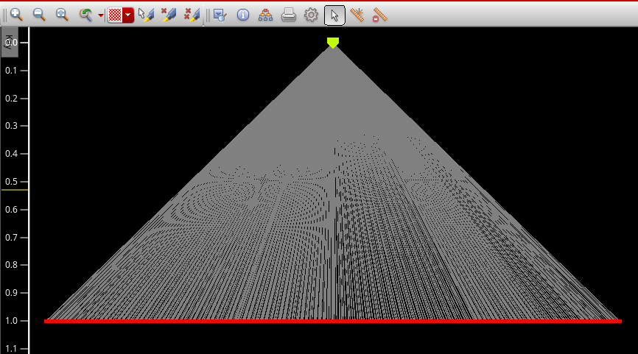

Fig. 16: Step- 7 Clock Tree

### ccopt.spec report:

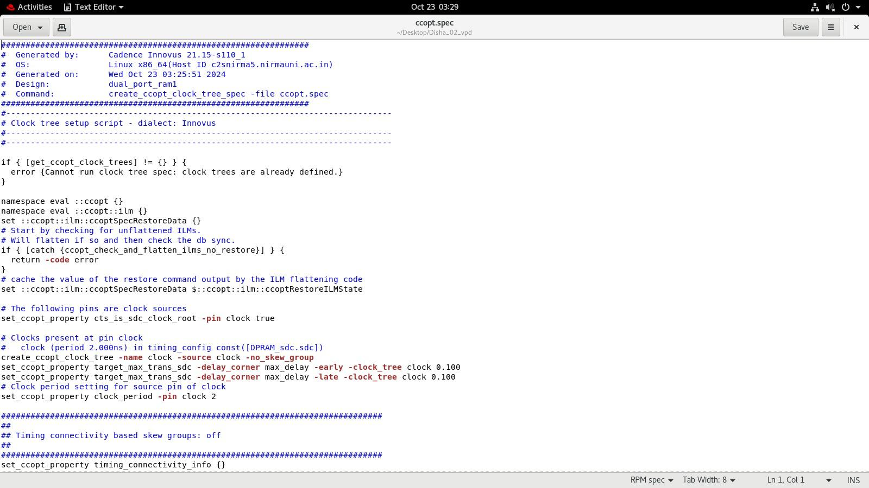

Fig. 17: ccopt.spec report

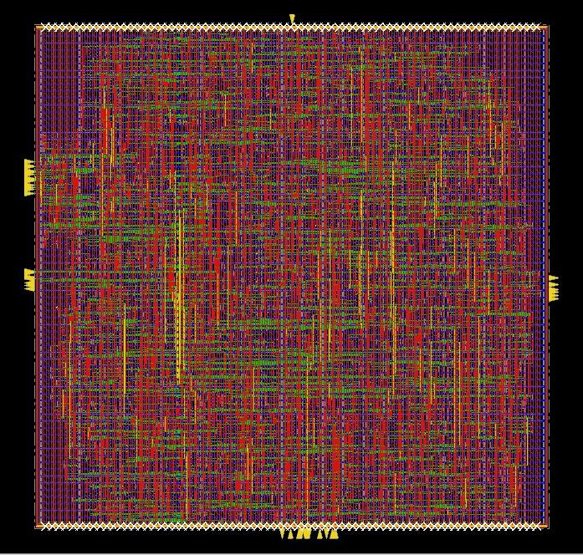

Fig. 18: Clock tree added in design

## Post-CTS analysis Setup and Hold time

Fig. 19: Post-CTS Setup report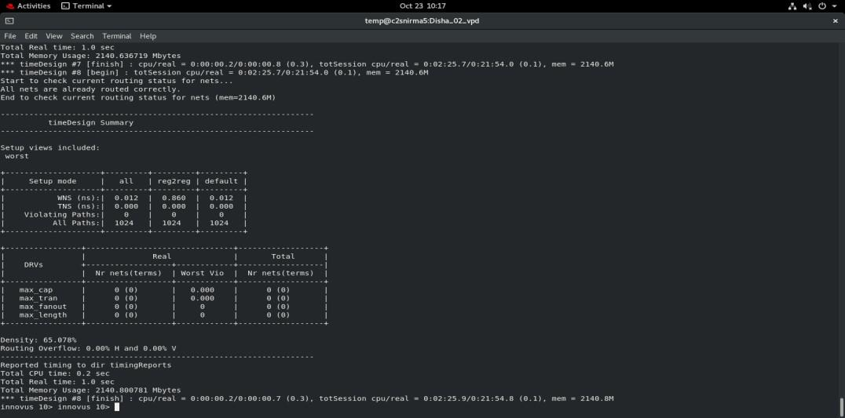

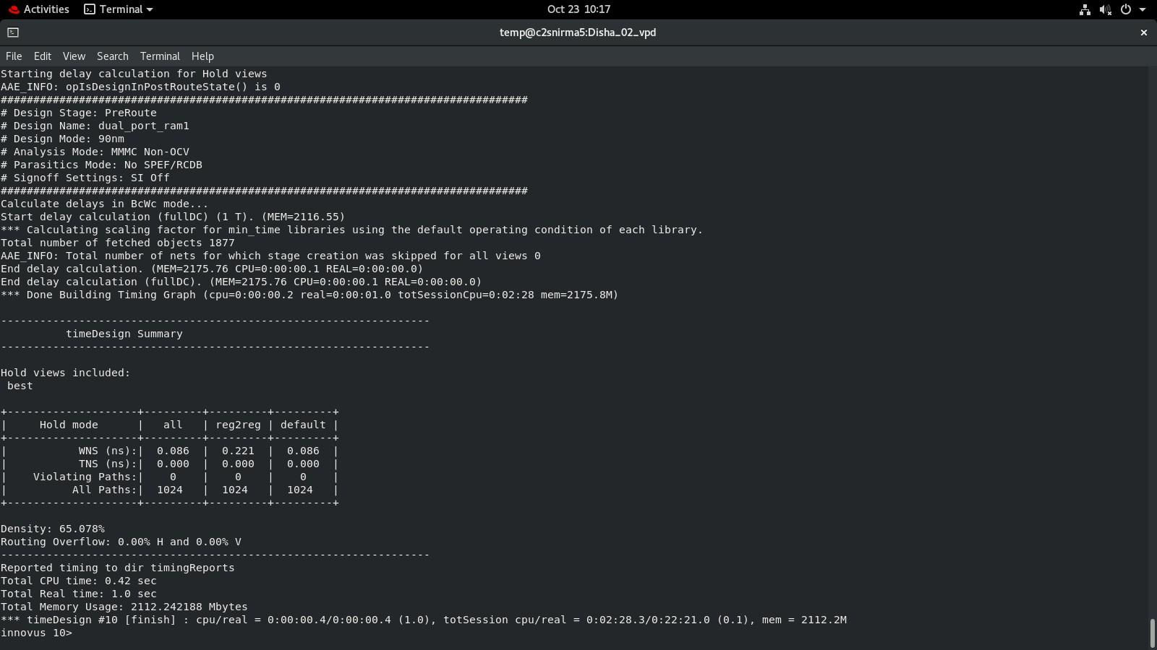

Fig. 20: Post-CTS Hold report

## Post Route Timing Analysis

Fig. 21: Post-Rout setup report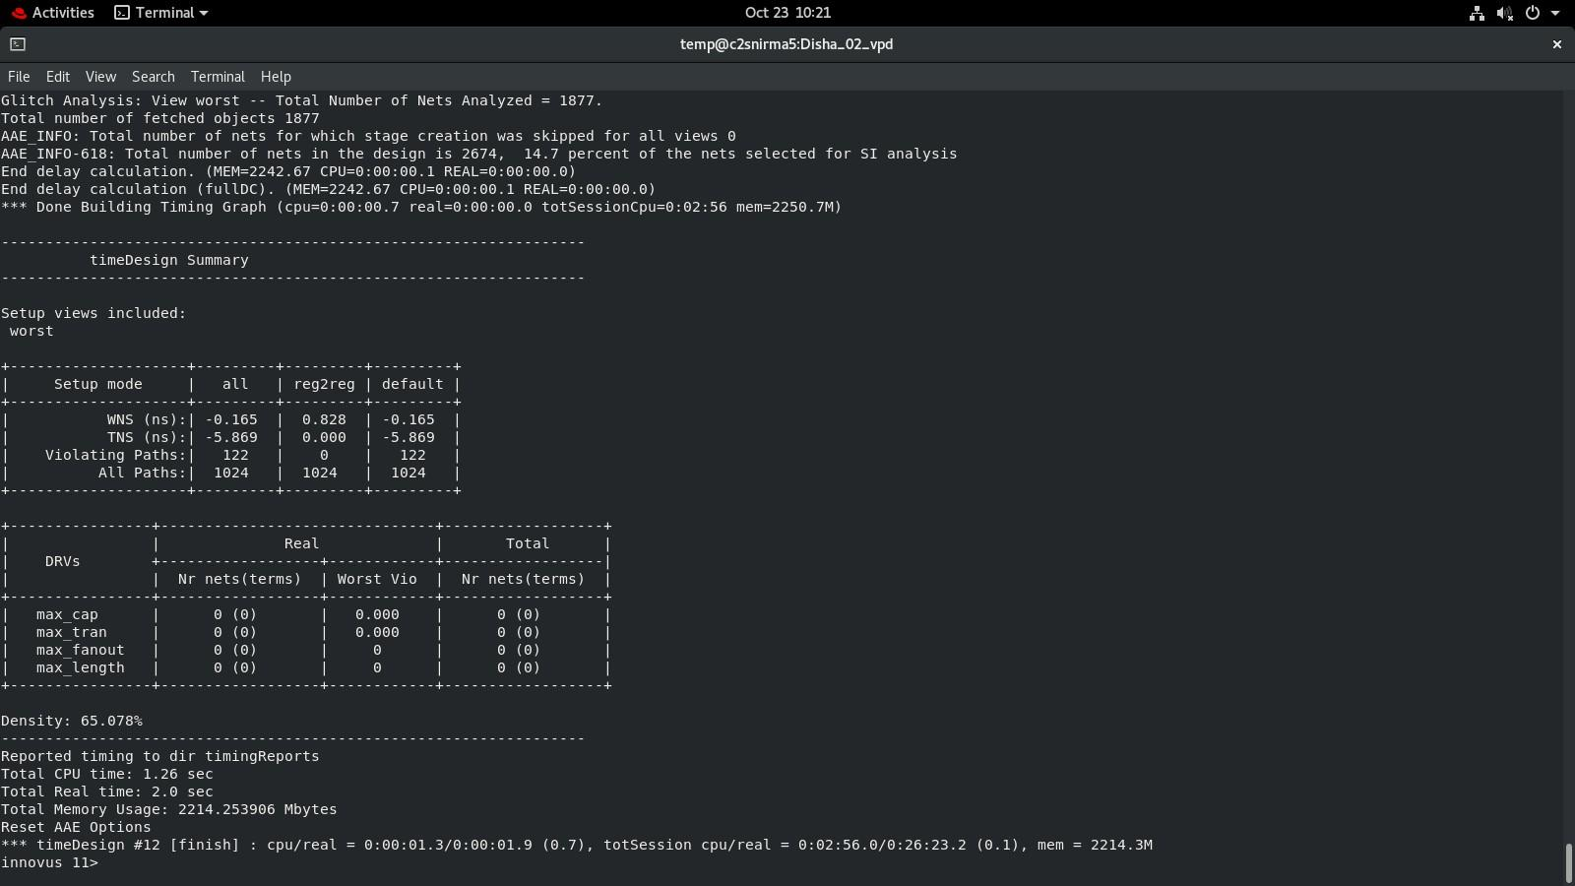

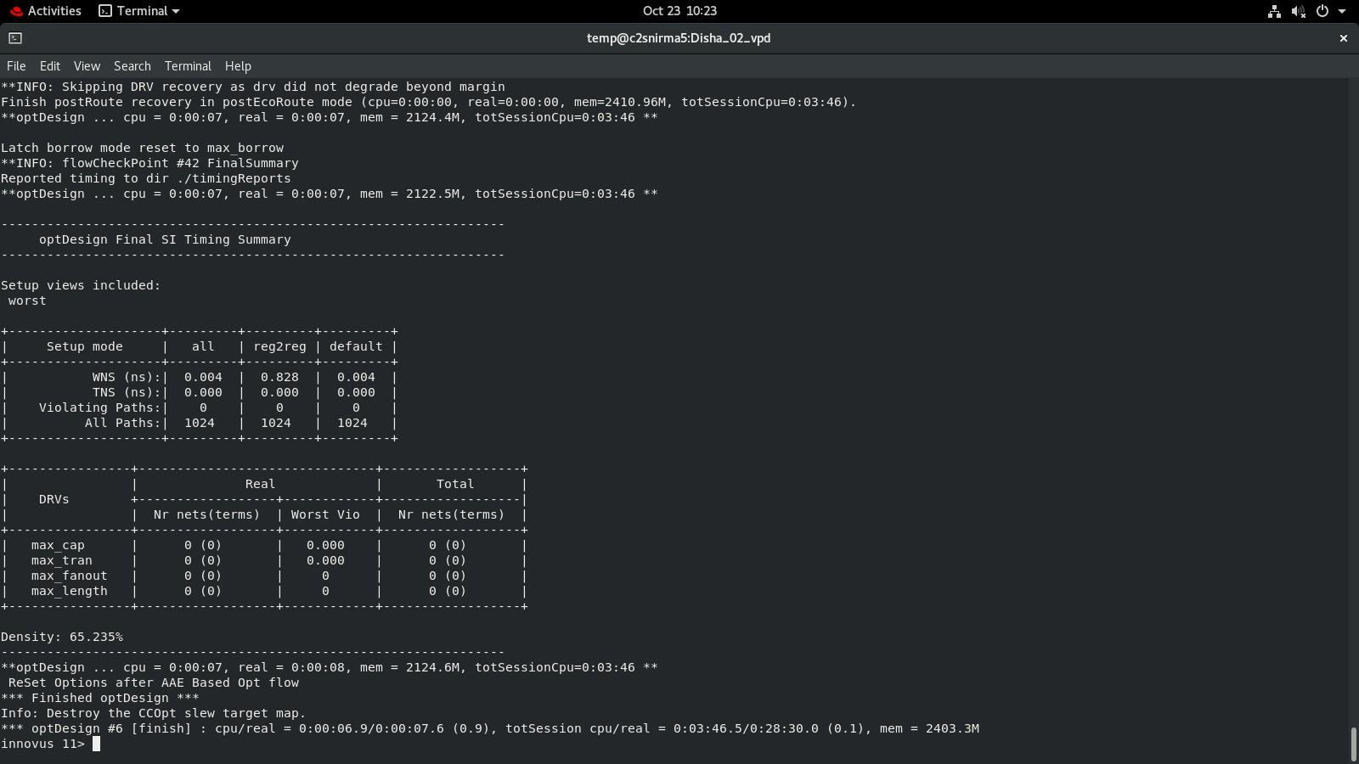

Fig. 22: Post-Rout optimized setup report

## Nano Routing

### Step 8: Nano Route (Final Layout)

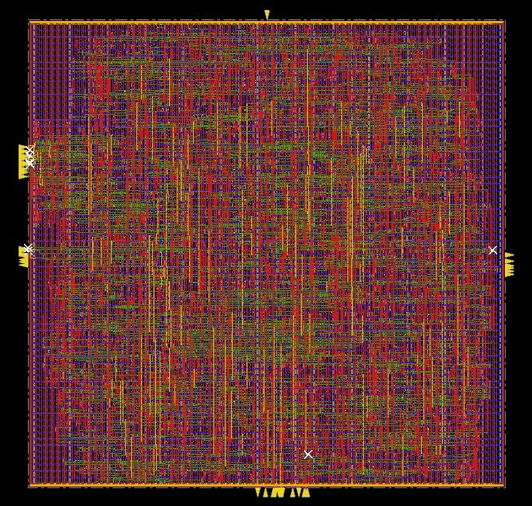

Fig. 23: Step- 8 Nano Route done (Final Layout)

## Timing Analysis

### ◎ Time period – 1 ns

### ◎ Operating frequency – 1 GHZ

### ◎ Total standard cells -4056

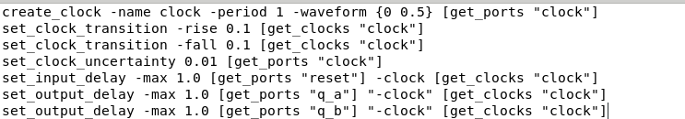

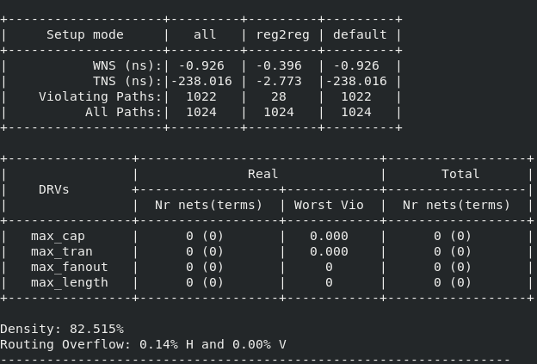

Fig. 24: Timing report when frequency is 1GHZ

### ◎ Time period – 1.3 ns

### ◎ Operating frequency – 0.75 GHZ

### ◎ Total standard cells -4049

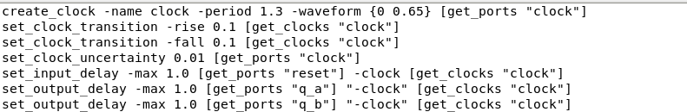

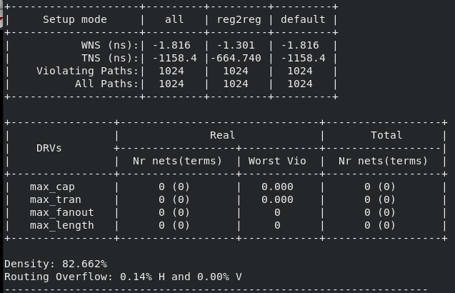

Fig. 25: Timing report when frequency is 0.75GHZ

### ◎ Time period – 2 ns

### ◎ Operating frequency – 0.5 GHZ

### ◎ Total standard cells -2032

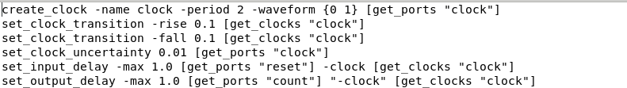

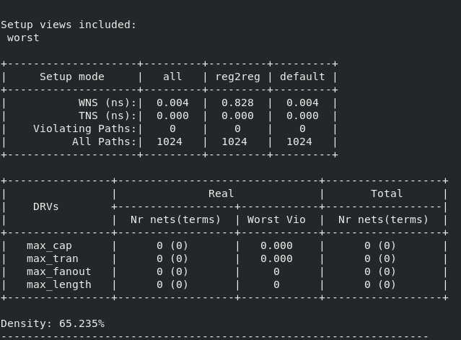

Fig. 26: Timing report when frequency is 0.5 GHZ

**Why there is a huge difference in number of standard cells?**

When you increase the targeted clock frequency for an ASIC design, several factors can lead to an increase in the number of standard cells used in the design:

Increased Timing Constraints: Higher clock frequencies require tighter timing constraints, which can lead to more complex logic arrangements to meet setup and hold times. This often necessitates additional standard cells for buffering and optimization.

Reduced Signal Propagation Delay: To achieve a higher frequency, the propagation delay through the logic gates must be minimized. This can involve using more cells with shorter delays, increasing the total number of cells.

Pipelining: To meet higher frequency requirements, designs often incorporate pipelining. This technique splits the logic into multiple stages, which increases the number of flip-flops and combinatorial logic cells.

Increased Use of Buffers and Repeaters: As clock frequency rises, more buffering may be needed to drive larger loads and maintain signal integrity, particularly for long interconnects.

Power and Area Trade-offs: Higher frequencies can also lead to trade-offs in power consumption and area. Designers might choose to utilize more cells to balance these aspects while maintaining performance.

Complexity of Logic: Some designs may require more complex logic functions to optimize for speed, leading to an increase in the number of standard cells utilized.

Optimization Techniques: Tools may optimize the design for area and speed, often resulting in more cells being instantiated to achieve the required performance.

In summary, achieving higher clock frequencies often requires more resources in terms of standard cells to ensure that the design meets the necessary performance criteria while maintaining reliability and signal integrity.

1. **Conclusion**

### In summary, The RTL to GDSII flow is a systematic and crucial process in VLSI design, converting a high-level digital circuit description into a manufacturable layout. Starting with RTL design and simulation, followed by synthesis to produce a gate-level netlist, each stage builds toward an optimized physical layout. The flow then moves through floor planning, placement, clock tree synthesis, and routing, ensuring that timing, power, and area requirements are met. Rigorous checks like DRC, LVS, and power analysis verify that the design meets both functional and fabrication standards. Cadence tools provide an integrated platform for managing this complex sequence, enabling thorough optimization and verification. The final GDSII file, a fully verified layout, is prepared for tape-out, making this flow essential for producing reliable, high-performance chips ready for fabrication.